Tuesday 2nd October 2018
Dear Parents/Carers,

I am really excited as our plans for our before and after school care club are well on their way.

We will be opening on Monday 5th November with plans to offer a holiday club in the future if there is enough interest. Please see below for the pricing structure and times available.

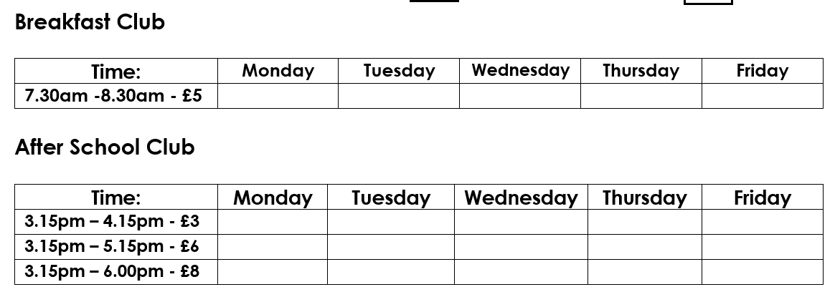
Care Club parent/carer agreement forms can be collected from the office and will need returning ASAP as the places will be issued on first come first served. If you do not collect your child, but wish to receive a form, please contact your child’s teacher or myself via dojo and we will send a form home.

Care club will take place in the demountable classroom with children also having access to the playground and field. All staff will be first aid trained and provide a range of activities for all ages.
All children attending in the morning will receive a breakfast selection to help fuel their day and children after school will receive a selection of light snacks which will vary each week.
Please, if you have any questions come and find me on the playground before or after school.

Thank you for your continued support

Mrs V Cameron
Principal

