Year 3 Newsletter Spring 1 2019
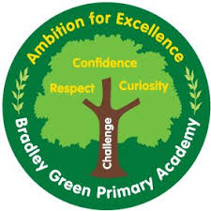

How you can help
PE – PE is on Wednesday and Friday. Please ensure your child’s full PE kit (pumps and outdoor trainers) is in school. Dojos for full PE kits!
HOMEWORK – Homework goes home on Tuesday and needs to be back in school the following Monday. It will consist of spellings (children will be tested on Monday), math’s skills and grammar homework.
SPELLING TESTS – Will be on a Monday. Certificate to be awarded for full marks!
HOME READING BOOKS – Reading books will be changed on a Monday, Wednesday and Friday. Please ensure that they are changed once a week.
READING RECORDS - Please bring reading records and books each day regardless of whether books need changing. We often do individual reading.

Science ROCKS!

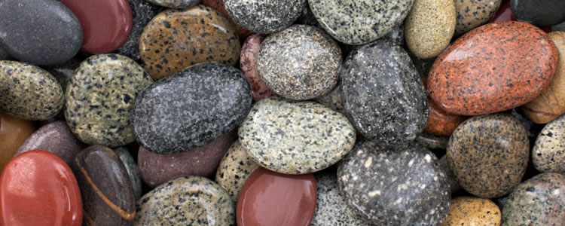
Our main topic this term will be “What can rocks tell us about the earth?” We will be learning all about the different rocks and minerals that we can find in the ground.
In English we will be reading ‘Ug’ by Raymond Briggs. This will cross curricular link to our history topic.
In Maths we will be moving on to multiplication and division. We will be looking in particular at the 3, 4 and 8 times tables. Please encourage your child to learn these at home.
In Science we will be looking at where rocks come from and how they are created. We will look at fossils and the importance of fossils in studying creatures from millions of years ago. We will be learning about the importance of different rocks and their uses in everyday life, and how to clean dirty water only using rocks.
In Art we will be using rocks to create Anthony Gormley and Andy Goldsworthy inspired sculptures. We will be focusing on colour, texture and pattern to produce these pieces of art. We will be using rocks, leaves and natural materials in these sculptures.

In History we will be learning about life in early Britain. We will start with the Stone Age, finding out what life was like at that time, moving through to the Bronze Age and Iron Age.
Useful websites:

https://www.ttrockstars.com/
www.sumdog.com
@Y3BradleyGreen on Twitter
Class dojo
Follow our page Bradley Green Primary Academy on Facebook.

