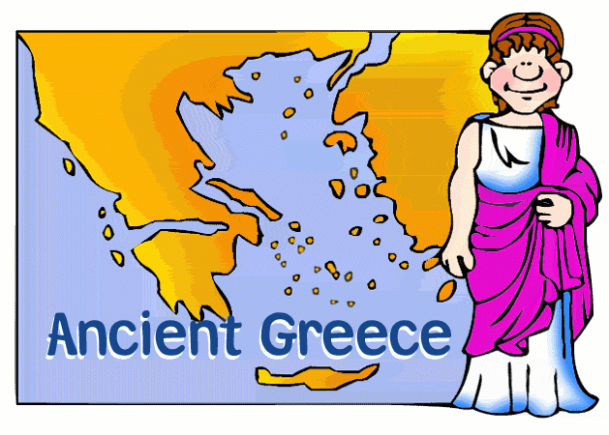
Year 3 Newsletter Autumn 1 2018

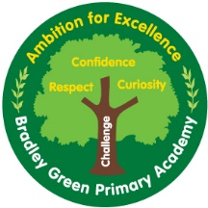

How you can help
MATHS –You can access www.sumdog.com for fun ways to help. We will be developing our understanding of place value, + - X ÷. Homework will sometimes also be set on Sumdog, so it is well worth a look at home.
PE – PE is on a Wednesday afternoon. Please ensure that your child has their PE kit in school. Also please remember no earrings on PE days. We will be swimming this year, but not until the Summer Term. 5 dojos for any child who has their full PE kit in school this week!
HOMEWORK – Homework goes home on Tuesday and needs to be back in school the following Monday. 5 dojos for fully completed and returned homework.
Each week I will be choosing a piece of work to win ‘Homework of the week’! The winning piece will be displayed on the wall and win a prize from the prize tin.
Maths will be based on what we have covered in the week or basic skills and English will be a reading comprehension or basic grammar skills. Children are expected to present their homework neatly – all maths in pencil and to use a ruler when underlining.
Miss Clayton and Mrs Relton would like to welcome you to Year 3! We hope you all had a lovely summer, and are ready for the exciting challenges of KS2. We are really looking forward to getting to know all the children, and seeing how they develop as individuals over the year.
This term … We start with place value, leading us to addition and subtraction. Support from home will be invaluable to ensure the children will be able to access everything in Year 3.
In English we will be reading ‘Leon and the place between’, by Grahame Baker-Smith. The children will have many rich writing opportunities from this text from predictions, letter writing, planning and producing our own parallel narrative. Please encourage your child to read at home this year. Regular reading promotes confidence and enjoyment in reading aloud. Children will be allocated a reading day so it is paramount that your child has their book in school on that day.
Our main topic is Ancient Greece. We will be finding out about what life was life for Ancient Greeks, why Gods were so important, and learning how the Greek armies were so successful. We are lucky enough to have a visit from the Living History Hub visiting on Friday 14th September. He will be running a range of activities with the children, exploring what life would have been like at this time. We need 2 parent helpers, so if you are able to join us to help, please let Miss Clayton know ASAP! We will be using this as our Ancient Greek day, your child will need to come to school dressed as an Ancient Greek. Any questions please don’t hesitate to ask the Y3 team.
In Science we are going to be learning all about shadows. How are shadows made, and is it possible to throw something we can’t touch?
Communication
Please don’t forget to connect to your child’s dojo account, I will be using it to send work selfies, and sharing our news on class story. 5 dojos for all children who have connected parents!
The dojo account is a brilliant tool to send messages, so please feel free to use it to send messages into school. I’m looking forward to sending lots of positive messages home about brilliant work.
Twitter: @Y3bradleygreen

